24th Super Bock Super Rock

New line up announcement:
THE ALCHEMIST
PARCELS
PRINCESS NOKIA
Announced so far:
19 JULY: The xx, Justice, The Vaccines, Lee Fields & The Expressions, TORRES
20 JULY: Anderson .Paak & The Free Nationals, Travis Scott, Slow J [PT], Tom Misch, Oddisee & Good Company, Olivier St. Louis
21 JULY: Julian Casablancas & The Voidz, Jorja Smith, Sevdaliza, Baxter Dury
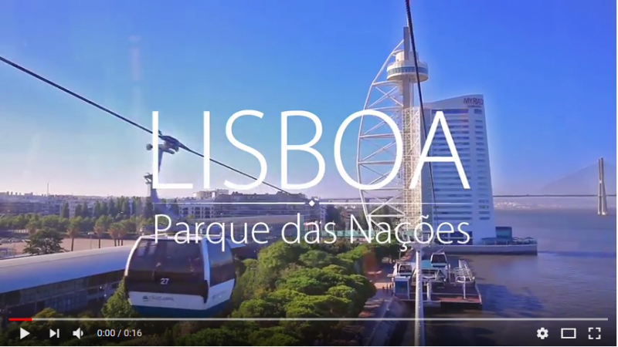

Combine a summer sun holiday and music festival with Super Bock Super Rock.
Tickets on sale!
Book your ticket in advance with the new deposit scheme.

July 19, 20, 21, Parque das Nações - Lisboa
www.superbocksuperrock.pt | facebook.com/sbsr

On July 19, 20 and 21, eclecticism is once again one of the strengths of Super Bock Super Rock, with the most authentic music of the moment spread out by the different stages across Parque das Nações in Lisbon. And there are great news for two of these stages: Parcels and Princess Nokia will perform at the EDP Stage on July 19 and 20, respectively, and The Alchemist (Eminem’s official DJ) performs at the Somersby Stage on July 20.

THE ALCHEMIST

(foto + links)

Alan Daniel Maman known as The Alchemist for the music world is one of today’s leading producers. Since his adolescence that he has been finding in hip-hop the ideal medium to express himself, writing his own lyrics, with an urban and rebellious spirit. Nas, Fat Joe, Jad Kiss or Snoop Dogg are notable witnesses of his skills. In addition to all of his work as a producer, he has also recorded three solo albums, all of them highly recommended: “1st Infantry” “No Days Off” and “Chemical Warfare”. He is currently Eminem’s official DJ with whom he will be touring in 2018. However, he has already confirmed his visit to Portugal to liven up the Somersby Stage in Super Bock Super Rock, July 20.

PARCELS

(foto + links)

Parcels were born in Australia, in the coastal town of Byron Bay but in the meantime they have settled in Berlin, Germany. Despite the change, the band still maintains a certain Australian atmosphere, more familiar with the sun and the beach than with the grey climate of central Europe. Their EP “Hideout” reveals an electro-pop in love with the 70’s, pridefully using synthesisers to feed their funk, echoing Chic or even the late Bee Gees. In 2017, they released the single “Overnight” with Daft Punk’s collaboration - joining the restrict group of artists that have had the privilege to work with the mythical French band. “Overnight” is yet another irresistible dance invitation that can be heard on July 19, at the EDP Stage in Super Bock Super Rock.

PRINCESS NOKIA

(foto + links)

Princess Nokia is one of the most promising names in worldwide hip-hop, a living proof that hip-hop is one of the most dynamic genres of our days, offering so many new and captivating voices with each passing year - the young Destiny Nicole Fasqueri is undoubtedly one of them. A militant of feminist values and attuned to the queer culture, Princess Nokia doesn’t turn her face away from the battle, presenting a combative register. In 2014, she released her first album “Metallic Butterfly”, a record that showed a woman of causes, yes, but also an artist interested in music, summoning various genres and influences for the construction of her own language. The success of the album “1992 Deluxe” and tracks such as “Tomboy” show that the future belongs to Princess Nokia. And she will be conquering the future in short term,on July 20, at the EDP Stage, in Super Bock Super Rock.

ABOUT SUPER BOCK SUPER ROCK 2018
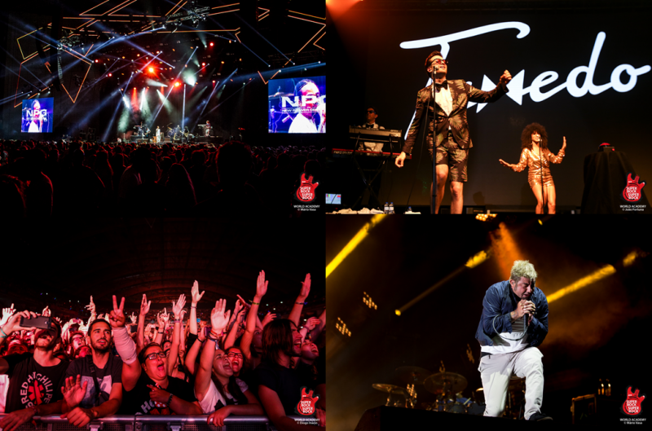
The festival takes place in one of the noble areas of the city where events of international reference take place such as the Web Summit, The Eurovision Final and other important trade shows and big entertainment events.
A place that brings together the best that Lisbon has to offer: convenient access from any part of the city through the transport network, proximity to the river Tagus with one of the best views of the city and still some of the best concerts in Europe on several stages, including the renowned Altice Arena.
This year it is even more convenient to guarantee your presence at Super Bock Super Rock in advance and plan your holiday week in Lisbon. In an exclusive partnership with Seetickets, it is possible to make an advance reservation of the 3-day pass with the deposit scheme.
Get a 3-day Super Bock Super Rock pass today with a security deposit of 55.00 EUR (plus full booking fee). You will have to pay the remaining EUR 54.00 until Friday 27 April 2018. Please note that if you do not pay the remaining amount until the date indicated, you will NOT receive a refund of the deposit and the ticket for the festival you will not be assured.
Super Bock Super Rock location is not only stunning but also convenient with top-quality transport links that bring you right on site, including a metro ride that takes just five minutes from the airport, and an excellent overall set-up for you to enjoy the best live music. All this for just €109 for a 3-day pass.

Already Confirmed:

July 19
Super Bock Stage – The XX, Justice
EDP Stage – The Vaccines, Lee Fields & The Expressions, Parcels, TORRES
Somersby Stage - Mahalia

July 20
Super Bock Stage – Travis Scott, Anderson .Paak & The Free Nationals, Slow J
EDP Stage – Tom Misch, Oddisee & Good Company, Princess Nokia, Olivier St. Louis
Somersby Stage – The Alchemist, Pierre Kwenders

July 21
Super Bock Stage – Julian Casablancas & The Voidz, Benjamin Clementine
EDP Stage – Jorja Smith, Baxter Dury, Sevdaliza
Somersby Stage – Sofi Tukker

