24th Super Bock Super Rock

STORMZY
Live debut in Portugal, July 21 at Super Bock Stage

Due to unforeseen schedulle reasons, unfortunately Jorja Smith had to cancel her performance at Super Bock Super Rock.

Announced so far:
19 JULY: The xx, Justice, The Vaccines, Lee Fields & The Expressions, Parcels, TORRES, Mahalia
20 JULY: Travis Scott, Anderson .Paak & The Free Nationals, Slow J [PT], Tom Misch, Oddisee & Good Company, Princess Nokia, The Alchemist, Olivier St. Louis, Pierre Kwenders
21 JULY: Julian Casablancas & The Voidz, Benjamin Clementine, Sevdaliza, Baxter Dury, Sofi Tukker
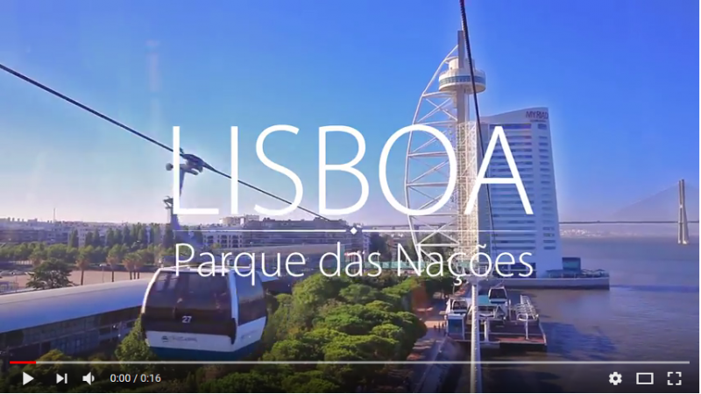

Combine a summer sun holiday and music festival with Super Bock Super Rock.
Tickets on sale!

July 19, 20, 21, Parque das Nações - Lisboa
www.superbocksuperrock.pt | facebook.com/sbsr

We’re less than three months away from the next edition of Super Bock Super Rock! Artists such as Travis Scott, The XX, Justice, Benjamin Clementine, among others, will guarantee the quality that has always been the brand of this festival. And there’s one more name to make the invitation even more irrefutable: the British Stormzy, for the first time in Portugal, will go on Super Bock Stage on July 21.

STORMZY

(foto + links)

Awards, nominations, thousands of records sold, record hits on the internet and expert critics at his feet make Stormzy one of the men of the moment. Of a Ghanaian origin, Michael Omari (the rapper’s real name) started singing early in life and in school, he was capable of the best and the worst: sometimes he was expelled from classes, other times he would get the highest grades. Here are two characteristics that define the artist today: a nerving irreverence (see the latest controversy with Theresa May, British Prime Minister), but also a work ethic that has lead him to achieve so much in such a short time (he will only turn 25 in July).
Influenced by artists like Drake or Kanye West, Stormzy began uploading his freestyle series online in 2013, “Wicked Skengman”, firing his sharpest lyrics over classic grime beats. In 2014, he had his debut with the EP “Dreamers Disease”. The rapper also stands out for creating his own rules to promote his music, trying to depend on no one. He won an award from the Independent Music Association and in BBC’s words: “no other artist has taken the traditional music business model of how to make, market, create, break, tour and monetise a new musical artist and flipped it on its head in the way Stormzy has in the last 24 months.”
In 2017, he released “Gang Signs & Prayer”, an immediate success to the point where he was able to get all of the songs on Spotify’s top 50 - something unprecedented so far. Everything in this record is thought out in detail along the 16 tracks and it is part of an artistic concept completely idealised by Stormzy (the cover, for example, is an interpretation of the “The Last Supper” by Leonardo da Vinci). Tracks such as “Big for Your Boots”, “Cigarettes & Cush” and “Don’t Cry for Me” leave no doubt about the rapper’s quality. And in the meanwhile he has already won another two awards with this record: At the 2018 Brit Awards, he’s won British Male Solo Artist and Best British Album. This year can only continue in strikes of perfection for Stormzy with his live debut in Portugal at the next edition of Super Bock Super Rock. Save the date: July 21, at the Super Bock Stage.

Due to unforeseen circumstances on the artist’s schedulle, Jorja Smith won’t be able to perform at the Festival.

ABOUT SUPER BOCK SUPER ROCK 2018

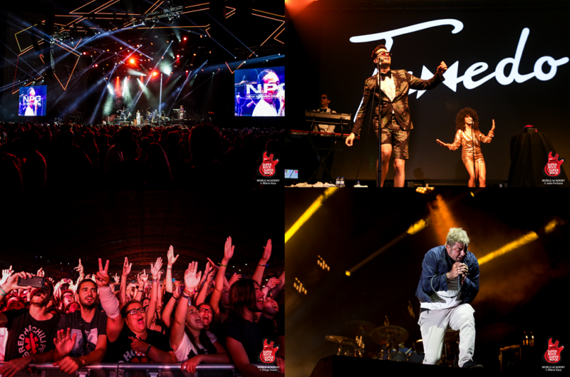
The festival takes place in one of the noble areas of the city where events of international reference take place such as the Web Summit, The Eurovision Final and other important trade shows and big entertainment events.
A place that brings together the best that Lisbon has to offer: convenient access from any part of the city through the transport network, proximity to the river Tagus with one of the best views of the city and still some of the best concerts in Europe on several stages, including the renowned Altice Arena.
This year it is even more convenient to guarantee your presence at Super Bock Super Rock in advance and plan your holiday week in Lisbon. In an exclusive partnership with Seetickets, it is possible to make an advance reservation of the 3-day pass with the deposit scheme.
Get a 3-day Super Bock Super Rock pass today with a security deposit of 55.00 EUR (plus full booking fee). You will have to pay the remaining EUR 54.00 until Friday 27 April 2018. Please note that if you do not pay the remaining amount until the date indicated, you will NOT receive a refund of the deposit and the ticket for the festival you will not be assured.
Super Bock Super Rock’s location is not only stunning but also convenient with top-quality transport links that bring you right on site, including a metro ride that takes just five minutes from the airport, and an excellent overall set-up for you to enjoy the best live music. All this for just €109 for a 3-day pass.

Already Confirmed:

July 19
Super Bock Stage – The XX, Justice
EDP Stage – The Vaccines, Lee Fields & The Expressions, Parcels, TORRES
Somersby Stage – Mahalia
LG Stage by radio SBSR – Mirror People [PT], Filipe Sambado e os Acompanhantes de Luxo[PT], Vaiapraia e as Rainhas do Baile [PT]

July 20
Super Bock Stage – Travis Scott, Anderson .Paak & The Free Nationals, Slow J
EDP Stage – Tom Misch, Oddisee & Good Company, Princess Nokia, Olivier St. Louis
Somersby Stage – The Alchemist, Pierre Kwenders
LG Stage by radio SBSR – ERMO [PT], Luís Severo [PT], Virtus [PT]

July 21
Super Bock Stage – Julian Casablancas & The Voidz, Benjamin Clementine, Stormzy
EDP Stage –Baxter Dury, Sevdaliza
Somersby Stage – Sofi Tukker
LG Stage by radio SBSR – Pop Dell’Arte [PT], Keep Razors Sharp [PT], Sunflowers [PT]

